# Testing Oscar’s SOAP API with Postman

## Available soap functions:

To see available soap functions on your version of Oscar, go to the following url:

http://{oscar-url}/[oscar](http://localhost:8080/oscar/ws/?wsdl) [/ws/?wsdl](http://localhost:8080/oscar/ws/?wsdl)

Select the function you wish to test. In this case I will be using getDemographic from the DemographicWsService.

## Import a collection into postman:

Select import on any workspace in postman.

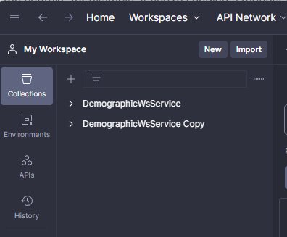

Paste [http://{oscar-url}/oscar/ws/DemographicService?wsdl](http://localhost:8080/oscar/ws/DemographicService?wsdl)

Select WSDL 1.1 with a Postman Collection and click import:

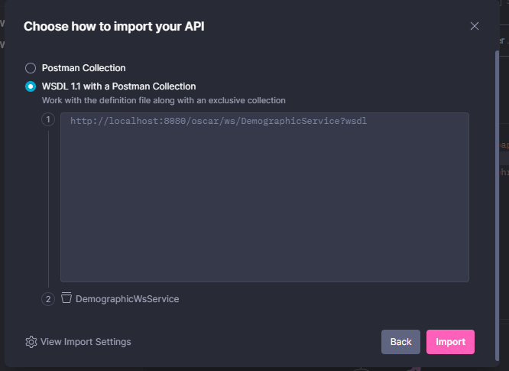

After selecting import, you should see the following functions in your selected workspace:

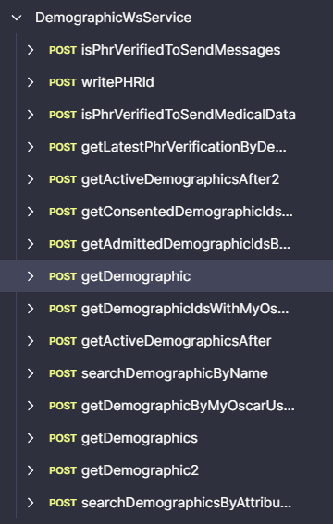

## Changes to package body:

Most functions require changes to the body before becoming usable. To start with, replace the soap envelope line with the following:

<soap:Envelope xmlns:soap="http://schemas.xmlsoap.org/soap/envelope/" xmlns:ws="http://ws.oscarehr.org/" xmlns:wsse="http://docs.oasis-open.org/wss/2004/01/oasis-200401-wss-wssecurity-secext-1.0.xsd" xmlns:wsu="http://docs.oasis-open.org/wss/2004/01/oasis-200401-wss-wssecurity-utility-1.0.xsd">

On the function call change the function line to:

<getDemographicIdsWithMyOscarAccounts xmlns="http://ws.oscarehr.org/">

To this: <ws:getDemographicIdsWithMyOscarAccounts>

Next, most functions require a header with an authenticated username and password. To add this header to a soap function, select the body on whichever service you wish to test.

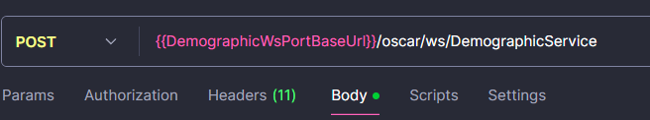

Next, Add the following above the soap:Body:

<soap:Header>

<wsse:Security>

<wsse:UsernameToken>

<wsse:Username>128</wsse:Username>

<wsse:Password Type="http://docs.oasis-open.org/wss/2004/01/oasis-200401-wss-username-token-profile-1.0#PasswordText">mac2002#</wsse:Password>

</wsse:UsernameToken>

</wsse:Security>

</soap:Header>

* The following fields in the soap:Header need to be changed
* <wsse:Username>
  + This can be changed to the security_no in the security table in the oscar database. (Run ‘select * from security’ on the oscar database.)
* <wsse:Password>
  + The password would be the login password for the provider that the security_no matches to.

After finishing your postman body should look like so:

<?xml version="1.0" encoding="utf-8"?>

<soap:Envelope xmlns:soap="http://schemas.xmlsoap.org/soap/envelope/" xmlns:ws="http://ws.oscarehr.org/" xmlns:wsse="http://docs.oasis-open.org/wss/2004/01/oasis-200401-wss-wssecurity-secext-1.0.xsd" xmlns:wsu="http://docs.oasis-open.org/wss/2004/01/oasis-200401-wss-wssecurity-utility-1.0.xsd">

<soap:Header>

<wsse:Security>

<wsse:UsernameToken>

<wsse:Username>128</wsse:Username>

<wsse:Password Type="http://docs.oasis-open.org/wss/2004/01/oasis-200401-wss-username-token-profile-1.0#PasswordText">mac2002#</wsse:Password>

</wsse:UsernameToken>

</wsse:Security>

</soap:Header>

<soap:Body>

<ws:getDemographic>

<arg0>1</arg0>

</ws:getDemographic>

</soap:Body>

</soap:Envelope>

Helpful documentation on both rest & soap:

https://worldemr.org/knowledge-base/oscar-emr-api/